AI ASSISTED CODING
ASSIGNMENT-10.4
NAME: Damera Prasanna Latha
ROLL NO:2503A51L37
BATCH: 24BTCAICSB20
Task Description#1 AI-Assisted Code Review (Basic Errors)
- Write python program as shown below.
- Use an AI assistant to review and suggest correction
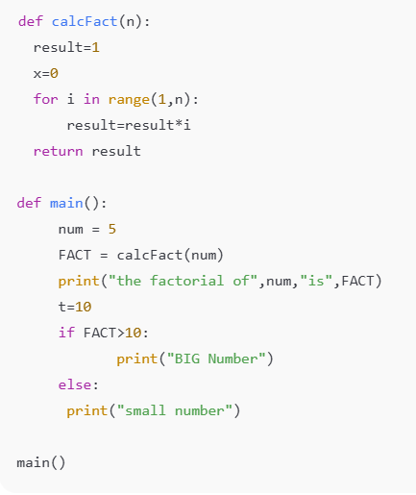
Expected Outcome#1: Students need to submit corrected code with comments.

PROMPT:Review the above code and suggest corrections.
rewrite the correct code with comments.

Corrections made in the code:

- The loop for i in range(1, n): is incorrect. It should be range(1, n + 1) to include n itself.
- Variable x = 0 in calcFact() is never used.
- In main(), num is defined, but passed to calcFact() as num, yet the function is called before num is declared as a parameter.
- The variable t = 10 is declared but unused.
- The if FACT > 10: is valid, but t being declared above has no effect.
- Use proper naming conventions (e.g., fact instead of FACT).
- Ensure consistent indentation and spacing for readability.
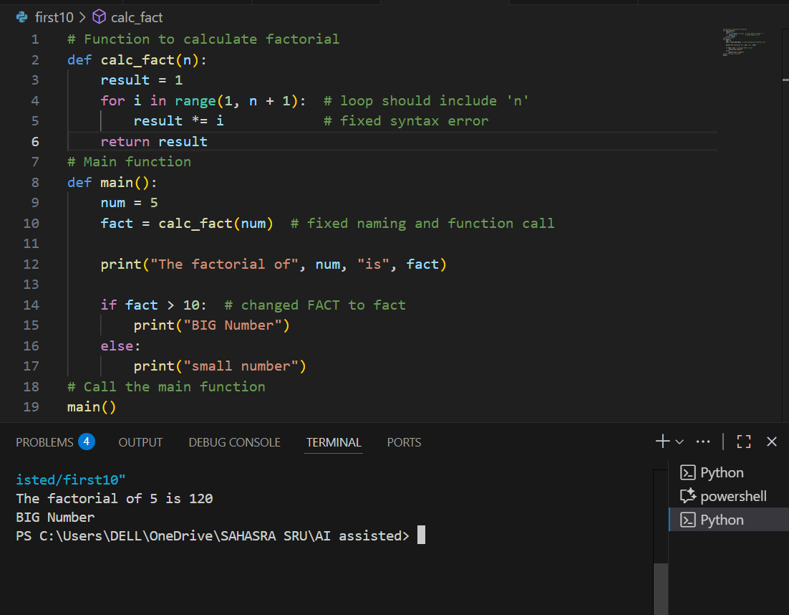

Task Description#2 Automatic Inline Comments
- Write the Python code for Fibonacci as shown below and execute.
- Ask AI to improve variable names, add comments, and apply PEP8 formatting (cleaned up).
- Students evaluate which suggestions improve readability most. one.

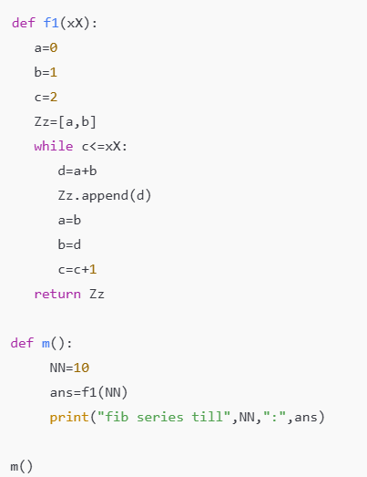

Expected Output#2: Clean format python code with much readability.
PROMPT: improve variable names, add comments, and apply PEP8 formatting (cleaned up) for the above python code
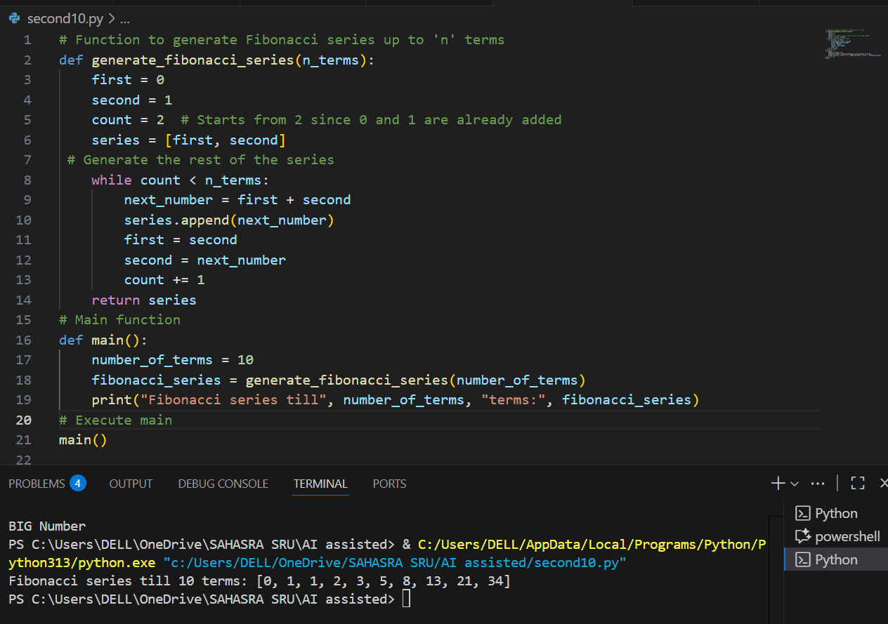
Key Improvements:
- Replacing a, b, c, Zz with first, second, count, series makes the logic self-explanatory.
- Function name generate_fibonacci_series tells you exactly what the function does.
- Original used while c <= xX, which actually generates xX + 1 terms, but your corrected code uses while count < n_terms, which properly limits the list to exactly n_terms values.
- Each logical block now has a comment — helps learners or future readers quickly understand what the code is doing.
- PEP8 style: consistent spacing, indentation, and line length.
- Your code looks professional and beginner-friendly now.

Task Description#3
- Write a Python script with 3–4 functions (e.g., calculator: add, subtract, multiply, divide).
- Incorporate manual docstring in code with NumPy Style
- Use AI assistance to generate a module-level docstring + individual function docstrings.
- Compare the AI-generated docstring with your manually written one.

MANUAL CODE:
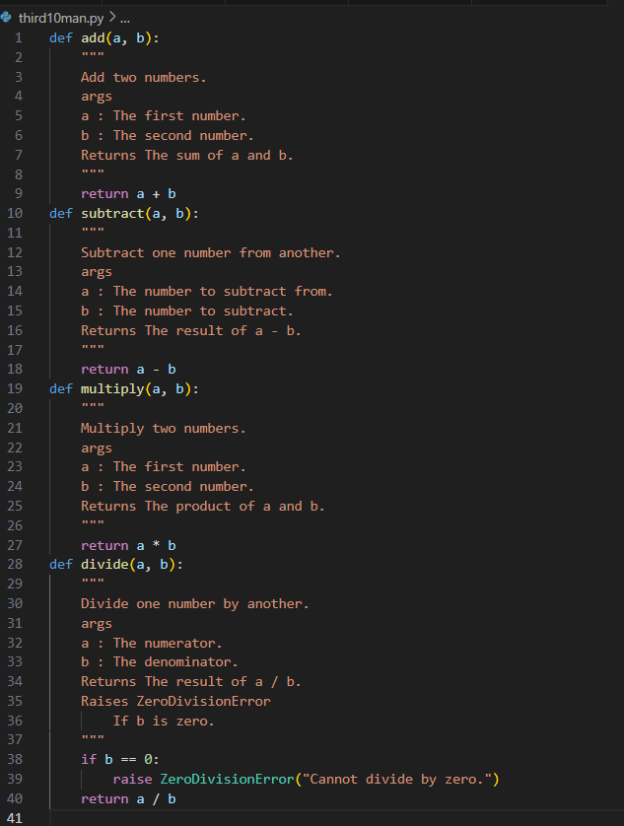

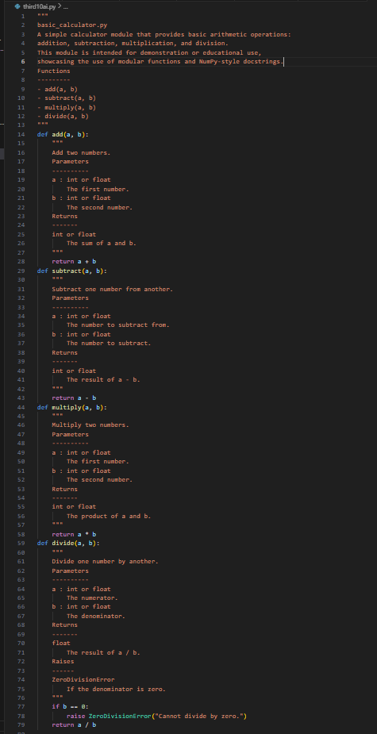
OBSERVATION:
• AI-assisted docstrings offer:
- Professional structure
- Better readability
- Tool compatibility
- Reusability in teams, APIs, and documentation websites
• ️ Manual comments are a good starting point for beginners, but lack structure and formal style, which may be insufficient for large or shared codebases.
The manual comments provide basic understanding but lack structure, standard formatting, and detailed type information. In contrast, the AI-assisted docstrings follow the NumPy documentation standard, offering clearer structure, better readability, and compatibility with professional tools. This makes them more suitable for collaborative and scalable projects.

